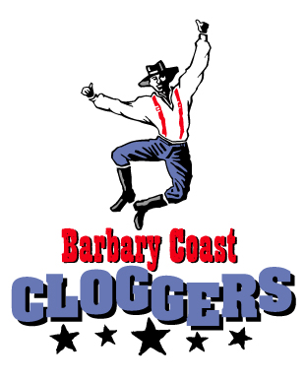

Official
Souvenir Order Form

Item | Circle Size | Quantity | Price | Total
Appalachian Overdrive DVD |  |  | $25
20th Anniversary t-shirt | S M L  XL 2XL |  | Sale!  $10
Jump t-shirt | S M L  XL 2XL |  | $20
Group Photo | Autographed  Not |  | $5
DVD/Anniversary shirt combo | S M L  XL 2XL |  | $30
TOTAL ORDER
Make check payable to “Barbary Coast Cloggers”
(Note: all prices include shipping)
Mail to: Barbary Coast Cloggers
P.O. Box 14164
San Francisco, CA 94114
Ship to: __________________________________________________

__________________________________________________

__________________________________________________

Phone ( )_______________________________________

 Check here to join the BCC fan e-mail list if you would like to receive occasional notices about performances. Your information will not be shared, sold, or traded. E-mail address:____________________________________

